Object Model

RuleSetDefinition.dll
This assembly generally encapsulates the functionality required to take the XML rule definition stored in the database (plain English like xml that is defined by the user when manipulating rules from the Centris Website), and represent it in an object called a RuleSetDefinition. This object model is what is consumed by the MSRuleSetTranslation.dll to Translate into a .NET RuleSet object. Also this assembly contains the RuleSetMetaDataDefinition class which encapsulates the functionality to Retrieve the Configuration Data and represent it defined in the Rule Fields and Rule Operators configurations. This object is loaded once and populated with the configurations and then consumed by the Translator in order to do the translation from RuleSetDefinition into a .net RuleSet.
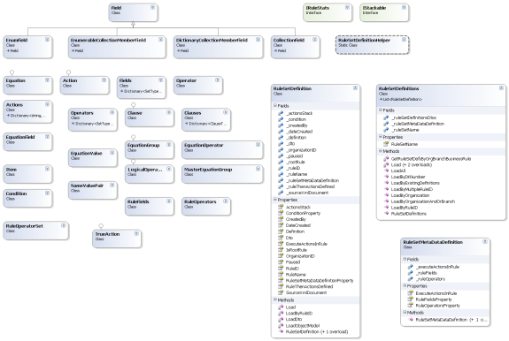

MSRuleSetTranslation.dll
This assembly generally encapsulates the functionality to take the RuleDefinition or RuleDefinitions collection of RuleDefinition objects and translate those into one .NET RuleSet object. Calling to the static generic RuleDefToRuleSet<T>.Translate(…)will return a MSRuleSetTranslationResult which contains the .NET RuleSet object and the meta data etc in regards to the translation and the RuleDefinition/s that the Translation was based on.
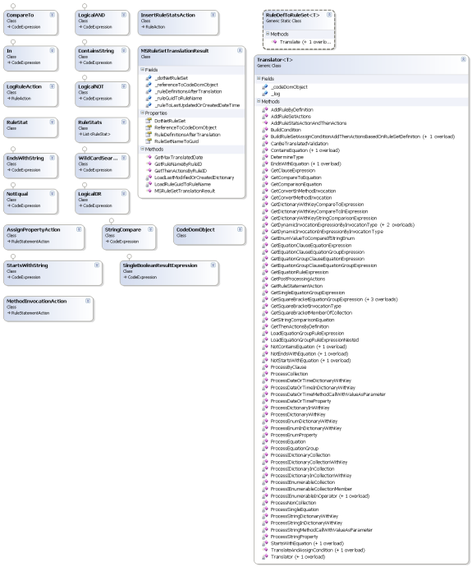

MSRuleSetExecution.dll
This assembly encapsulates the functionality to take a MSRuleSetTranslationResult or a .NET RuleSet object and exposes an Evaluate or Execute method. Call to the generic static ExecutionEngine<T>.Evaluate(…) or ExecutionEngine<T>.Execute(…) will call to the respective static generic Evaluator<T> or Executor<T> respectively.
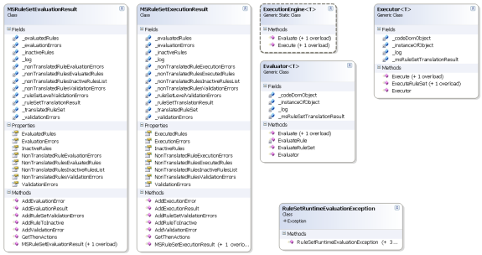

Sequence of Steps – Usage

Rule Definitions Translated into .NET RuleSet – "Translation Engine"
"Translation Engine" is not a true "Engine" per say it is merely at this time a static class that developers can reference and use from their projects. Once the Consumer has retrieved the pertinent Rule Definitions from the database, the "Translation Engine" static class is called to translate the Rule Definitions against the instance of the Type (Itinerary) and returns a MSRuleSetTranslationResult object which contains the .NET RuleSet object and any relevant meta data about the translation including validation errors, exceptions, and the rule definitions themselves with their keys etc. A note about the Translation, a flag is passed when the Translation occurs, this flag indicates whether this is a Translation that will be executed or not. In the execution scenario, the method calls at this time that are supported are to static methods outside of the type that we are defining rules against, public methods within the type we are defining rules against, and currently we do not create calls to methods with parameters. This is default behaviour and above and beyond that you can create your own custom actions that can do any custom behaviour and add those to the ThenActions collection and ElseAction collections. This will be discussed in a later section.

Translated .Net RuleSet calls to Evaluate Methods – "Evaluation Engine"
"Evaluation Engine" is not a true "Engine" per say it is merely at this time a static class that developers can reference and use from their projects. An "Evaluation Engine" or an "Execution Engine" can be called to do either an Evaluate or an Execute on the .NET RuleSet object. Again the return from this is an MSRuleSetEvaluationResult or an MSRuleSetExecutionResult respectively. For Centris we pass in the MSRuleSetTranslationResult and call to Evaluate and get a MSRuleSetEvaluationResult object returned. This object contains the results of the call to the Evaluate on the .NET Rule Set object and also contains meta data about the evaluation, validation errors, exceptions, and the actual results of the evaluation of the conditions of the rules as True or False etc.

Post Processing – Processing Actions
Each Rule Definition defined by the user interface and stored in the db also has an "Action" associated with it. The user when defining the rule, will also choose the "Action" to take. This means "if the rule condition is true, then perform the Action". When the Execute is called in the "Evaluation Engine" then the Actions are actually method calls and have already been executed, however when calling to the Evaluate method as we do in Centris, those actions are not performed at runtime. So in Centris we find all the rules that evaluated to "True" and then we custom define what each of those actions means and then our code performs particular actions that represent the "Action" defined on the rule. The Evaluate() method is referred to in this document as "Post Processing", and the Execute() method is referred to as "Runtime Execution".

Wrapper Object or Actual Type Preparation
It is recommended (not absolutely required) that any Type that will have Rules defined against it be contained within a "Wrapper Object" and then Properties and Methods be exposed to access the actual object. Any Type that is to have rules defined against it must inherit from the class BaseRuleCollectionProcessing. The "Wrapper Object" approach makes this easier if not the only way possible to expose the Type because the actual Type may already inherit from another class. The Type that we defining rules against will be your "Wrapper Object" or the Type itself both of which must inherit from BaseRuleCollectionProcessing class which is found in assembly DotNetNancy.Rules.RuleSet.BaseRuleCollectionProcessingLibrary. Example: We have a RuleSetPNR class which is a "Wrapper Object" around the Itinerary Type. Not shown but as a private field we have an instance of an Itinerary object, then in the Properties and Methods sections we have declared public properties or methods that return our private Itinerary object's members or methods.
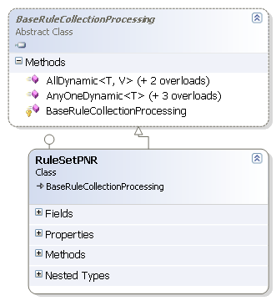
Also inside the "Wrapper Object" or the Class itself you can throw a custom rules exception called "RuleSetRuntimeEvaluationException" which can be found in the DotNetNancy.Rules.RuleSet.MSRuleSetExecution assembly.
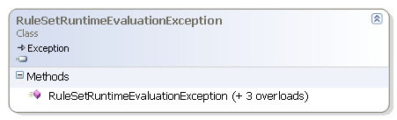

Notice also that the CollectionProcessingExtensions methods themselves actually call to a Generic CollectionProcessingExpressions class which is found in the LinqCollectionProcessingLibrary assembly to get the Lambda expression to pass to the regular LINQ Any(…) method. Just follow the same pattern. The developer is only responsible to create the Extension Method signature and the rest is done by Generic CollectionProcessingExpressions. This will support any number of types etc. Generally we do not assume "object comparison" but you can create any number of different permutations as the CollectionProcessingExpressionsLibrary is generic and does not care what type it is operating upon as long as it is one of our supported "types". These will be discussed in a later section on configuration. The property you are defining in the configuration must ultimately be of a primitive type ie string, int, double, enum etc. The property that you are working with can also be in the form of for example VehicleSegment.PropertyA.SubPropertyA and the CollectionProcessingExpressionsLibrary does a recursion until it gets to the actual property even if it is a few levels down.
